1. Sample execution of Bash script

Step 1: connect to AWS EC2 by using **ssh -i webserver-test-3.pem ec2-user@13.62.99.188**

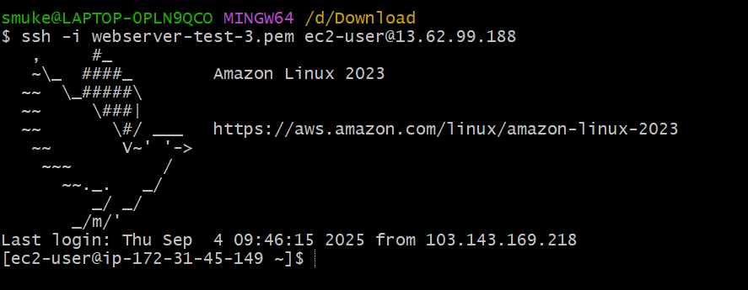

Step 2: create the file with the commands to be executed

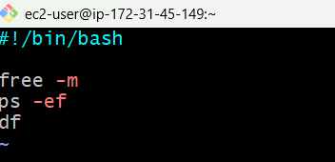

Step 2: give the execute permission to the file



Step 4:Execute the script by using ./file_name command

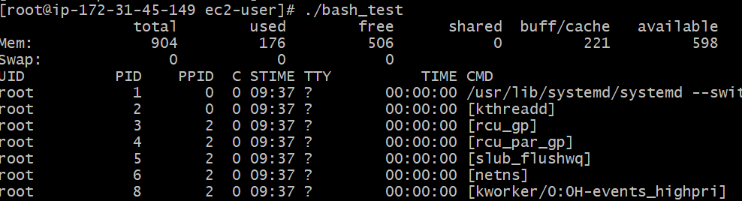

1. 1st Script

Step 1: Create a file and enter the data

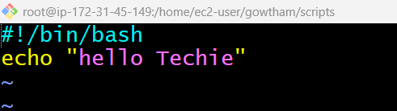

Step 2: give execute permission by using **chmod 777 filename**



Step 3: Execute it by using **./filename** or **bash filename**

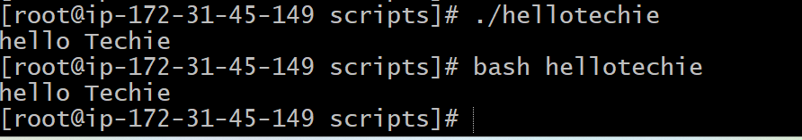

1. Proper Script

Step 1: create a file with the extension of shell name



Step 2: Enter the data to be executed

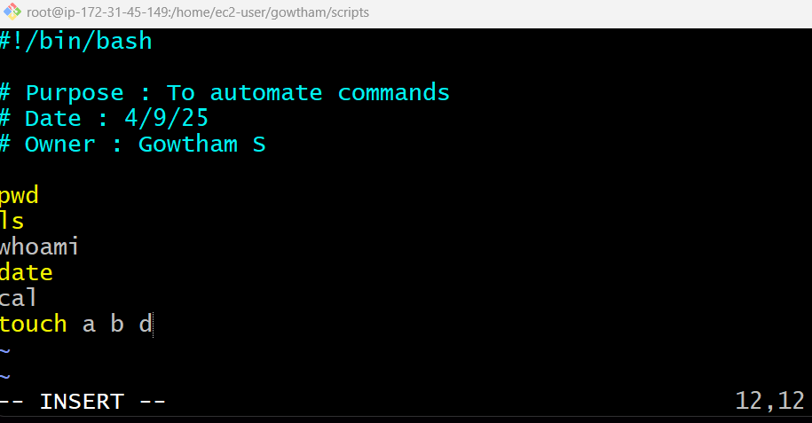

Step 3: Give execute permission **chmod 755 filename.shell**



Step 4: Execute it by using **./filename.shell**

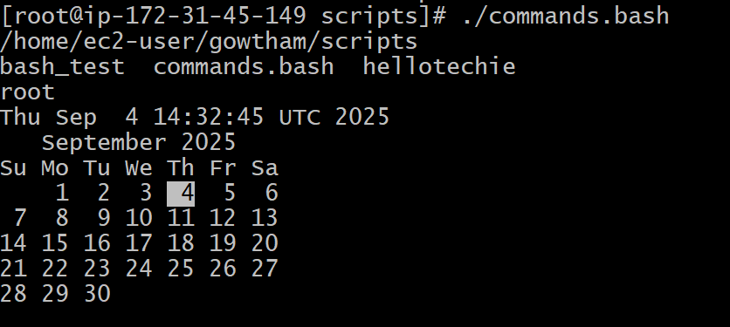

1. Automate Admin commands

Step 1: create a file with shell name as extension



Step 2: Enter the data

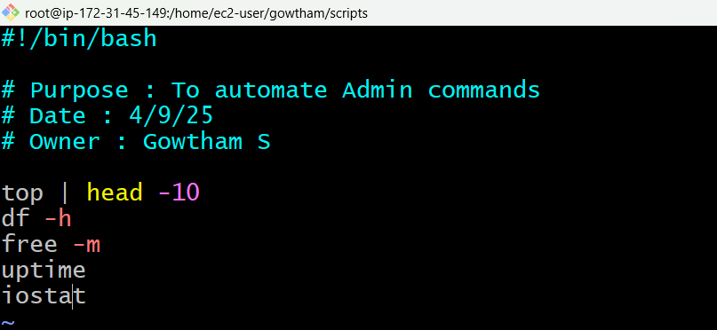

Step 3: Give execute permission to the file



Step 4: Execute it using **./filename.shell**

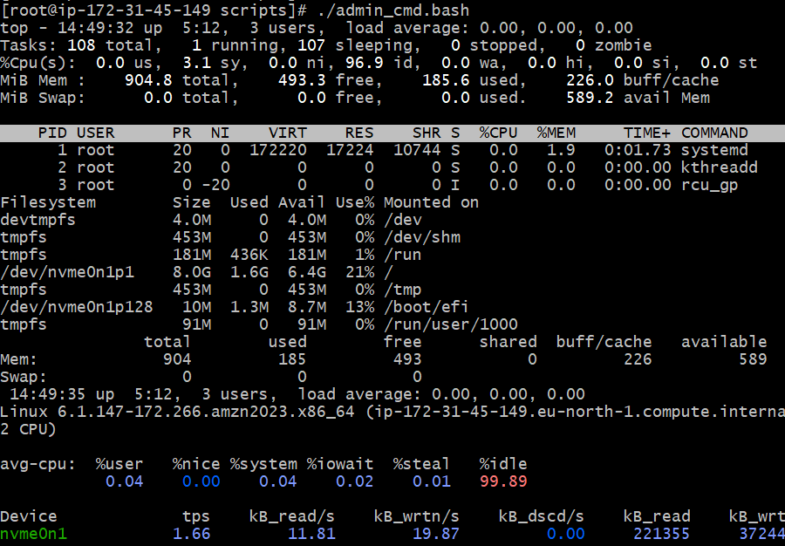

1. Create a script using variables

Step 1: create a file with shell name as extension



Step 2: Enter the data

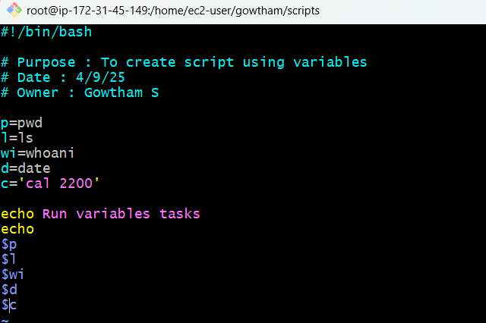

Step 3: Give execute permission to the file



Step 4: Execute it using **./filename.shell**

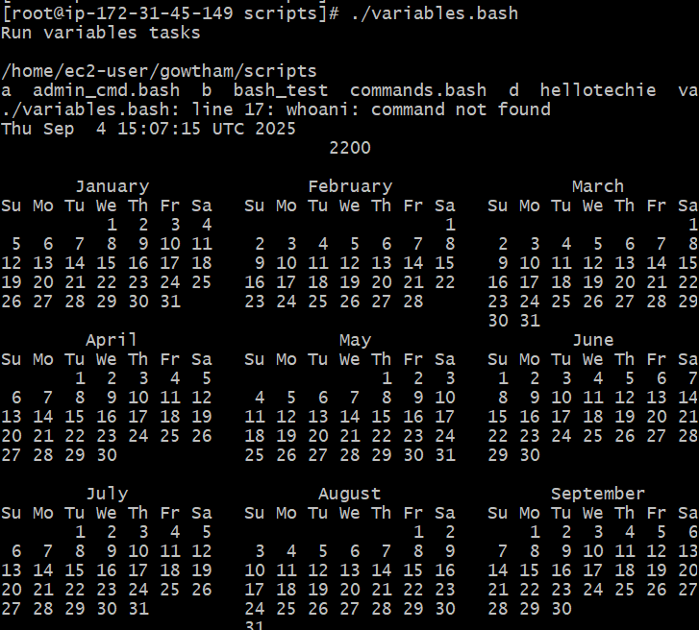

1. Create a script to get input from user

Step 1: create a file with shell name as extension



Step 2: Enter the data

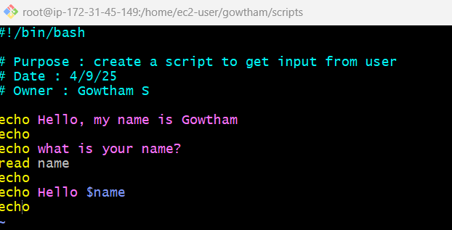

Step 3: Give execute permission to the file



Step 4: Execute it using **./filename.shell**

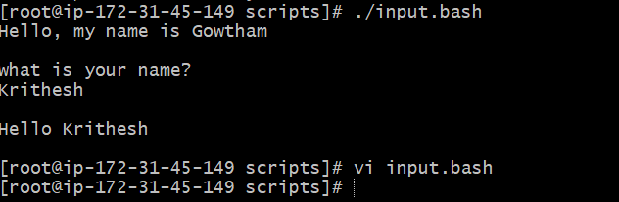

1. Create a script to execute a command in a variable

Step 1: create a file with shell name as extension



Step 2: Enter the data

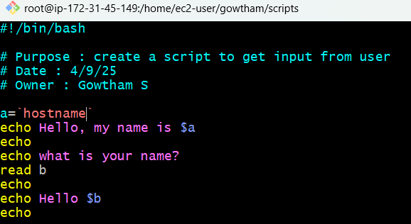

Step 3: Give execute permission to the file



Step 4: Execute it using **./filename.shell**

